PricePilot AI

Milestone 3 Documentation

Competitor Analysis & Revenue Optimization

PricePilot AI: Dynamic Pricing Optimization & Revenue Intelligence System

Objective
The objective of PricePilot AI is to develop an AI-powered dynamic pricing and revenue intelligence system that supports pricing decisions using demand, competitor pricing, customer behavior, sales performance, inventory, and market-related information.
The system is designed to support price prediction, competitor analysis, demand-based pricing, revenue optimization, pricing analytics, profitability monitoring, and business intelligence reporting.
For Milestone 3, the focus is on Competitor Analysis & Revenue Optimization, including competitor monitoring, pricing comparison, market intelligence, profitability analytics, pricing strategy recommendations, and executive business intelligence reporting.

Milestone 3 Scope
Milestone 3 focuses on developing the Competitor Analysis & Revenue Optimization capabilities of PricePilot AI.
The major scope of this milestone includes:
- Implementing competitor monitoring workflows.
- Generating pricing comparison reports.
- Building market intelligence modules.
- Developing profitability analytics dashboards.
- Generating pricing strategy recommendations.
- Building executive business intelligence reports.
The milestone is intended to build competitor analysis and revenue optimization systems, implement profitability monitoring and reporting workflows, understand market intelligence and pricing strategy concepts, and complete end-to-end pricing optimization workflows.

Data Source

Datasets Used
Five datasets were reviewed and collected for PricePilot AI. They cover complementary aspects of pricing, products, customer reviews, retail demand, competitor pricing, promotions, inventory, profitability, and economic conditions.
Dataset | Rows | Columns | Primary Purpose
Amazon Product Pricing & Reviews | 1,465 | 16 | Product price, discount, rating and review information
Amazon Product Pricing | 20 | 11 | Product pricing, discount, rating and stock information
Retail Price Optimization | 1,040 | 13 | Weekly price, competitor price and sales-volume analysis
Favorita Store Sales | 7,300 | 8 | Store/product demand, promotions, holidays and economic indicator
Integrated Pricing & Demand | 7,300 | 31 | Consolidated pricing, demand, competition, inventory and profitability dataset

Dataset Integration Rationale
The five datasets were not treated as interchangeable records. Each contributes a different business perspective.
The Amazon datasets provide product-level pricing, discount, rating, review, and stock context. The Retail Price Optimization dataset provides competitor-price and weekly-sales relationships. The Favorita dataset provides store-level demand, promotions, holidays, and an economic indicator. The Integrated Pricing & Demand dataset combines the main pricing, demand, competition, inventory, and profitability variables into one structured dataset.
The integrated dataset provides the main structured foundation for the PricePilot AI system, while the other datasets support validation, exploratory comparison, and feature understanding.

Tasks Completed in Milestone 3

1. Implement Competitor Monitoring Workflows
Competitor monitoring workflows are developed to examine competitor pricing information and understand the competitive pricing environment. The workflow uses pricing and market-related data to support comparison between the product price and competitor prices. This provides the foundation for identifying competitive positioning and pricing opportunities.
Screenshot: 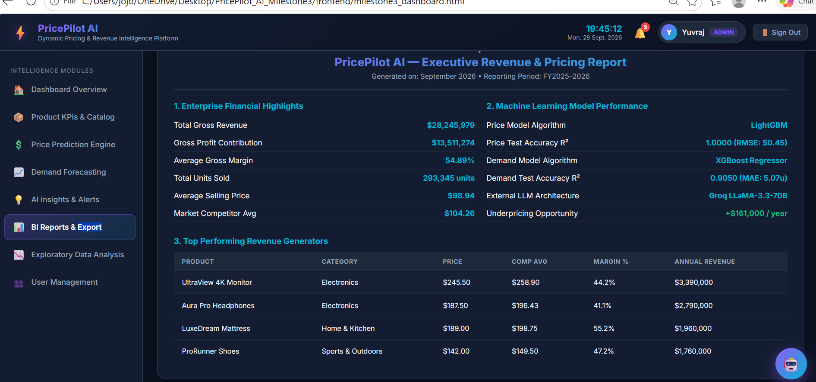

2. Generate Pricing Comparison Reports
Pricing comparison reports are generated to provide a structured view of product prices in relation to competitor prices. These reports help identify differences in pricing and provide information that can be used for pricing analysis and decision-making.
Screenshot: 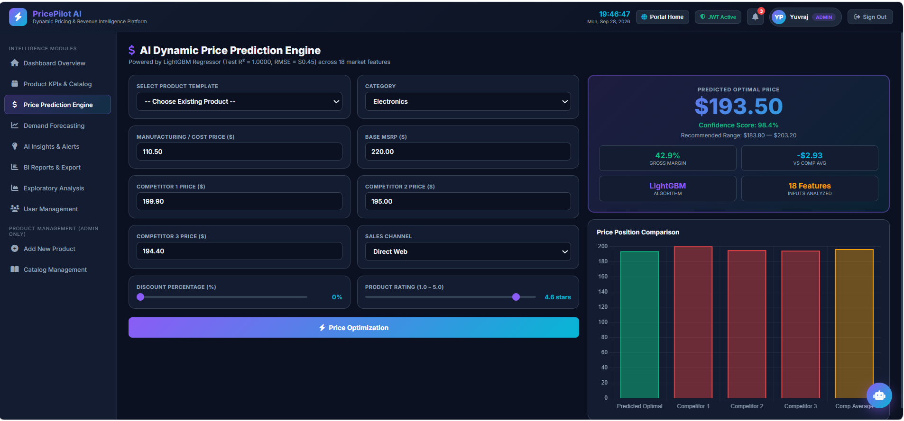

3. Landing Page
The landing page provides the initial interface of the PricePilot AI platform and introduces the system's dynamic pricing and revenue intelligence capabilities. It presents the platform's main purpose and provides users with access to the application.
Screenshot: 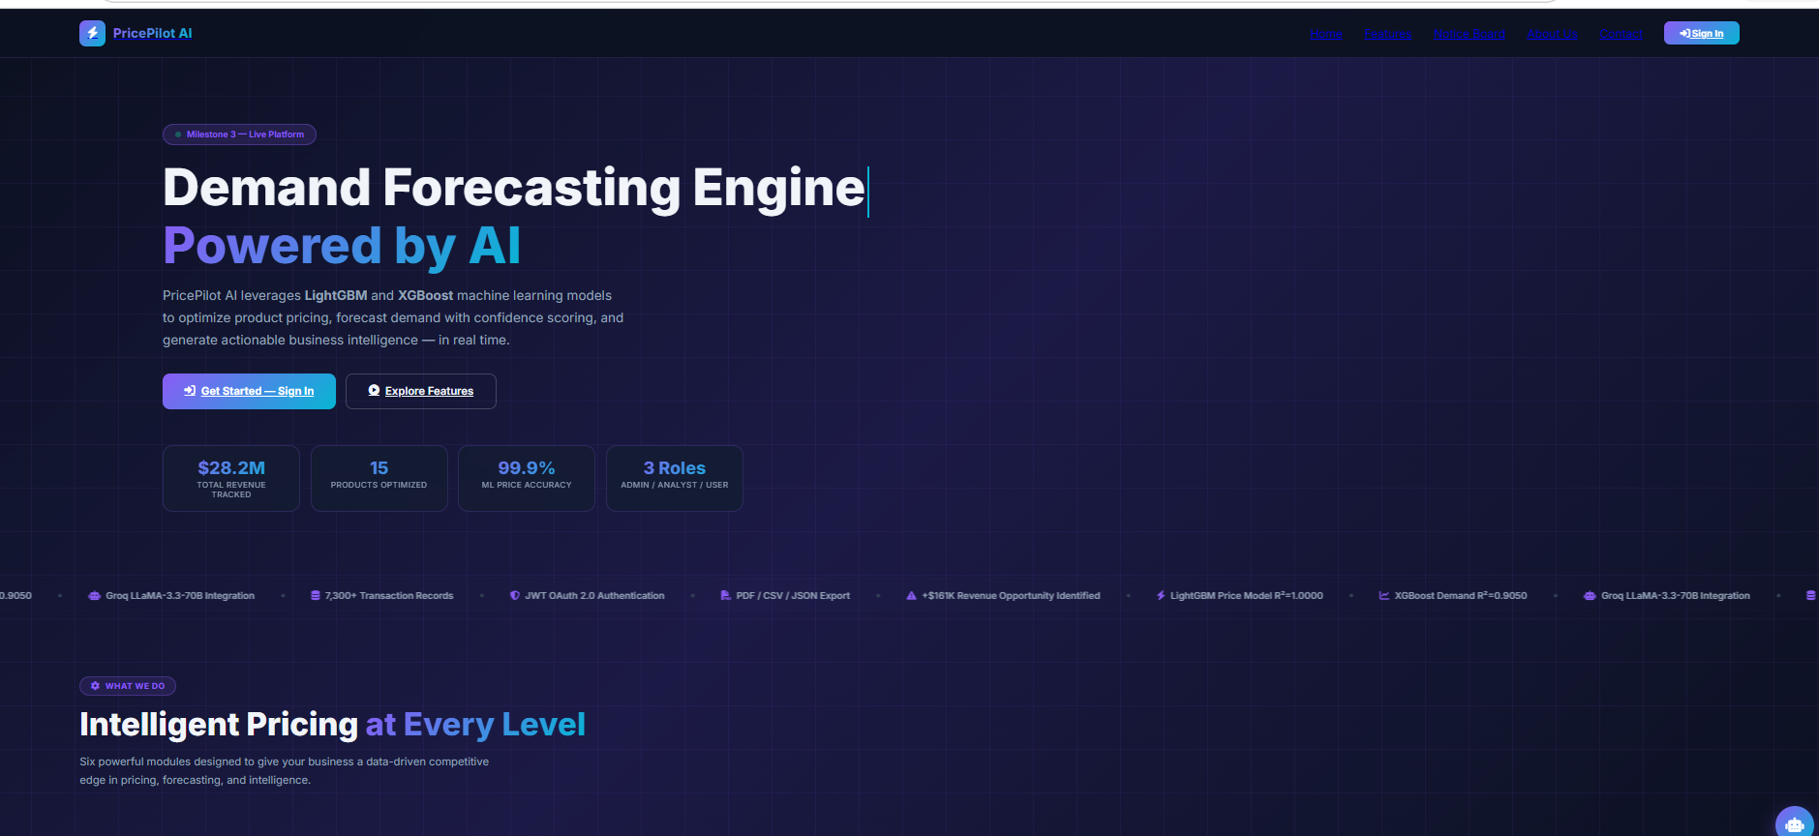

4. Sign Up Page/create account
The sign-up page allows new users to create an account and access the PricePilot AI platform. It collects the required user information and supports the initial user registration process before authentication and access to the system.

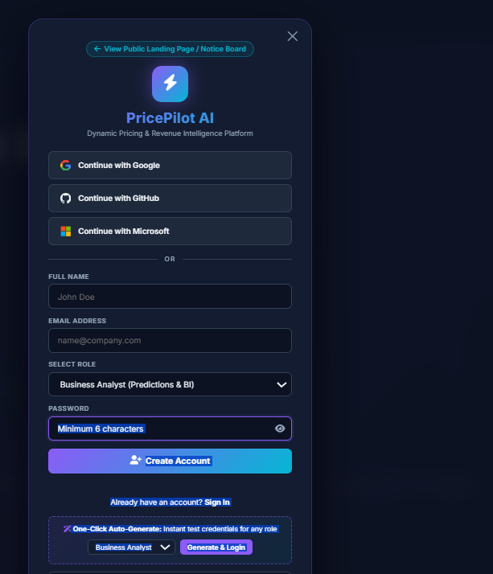

5. Login Page
The login page provides the entry point for users to securely access the PricePilot AI platform. It supports user authentication and controlled access to the system based on the implemented user-management and access-control functionality.
Screenshot:
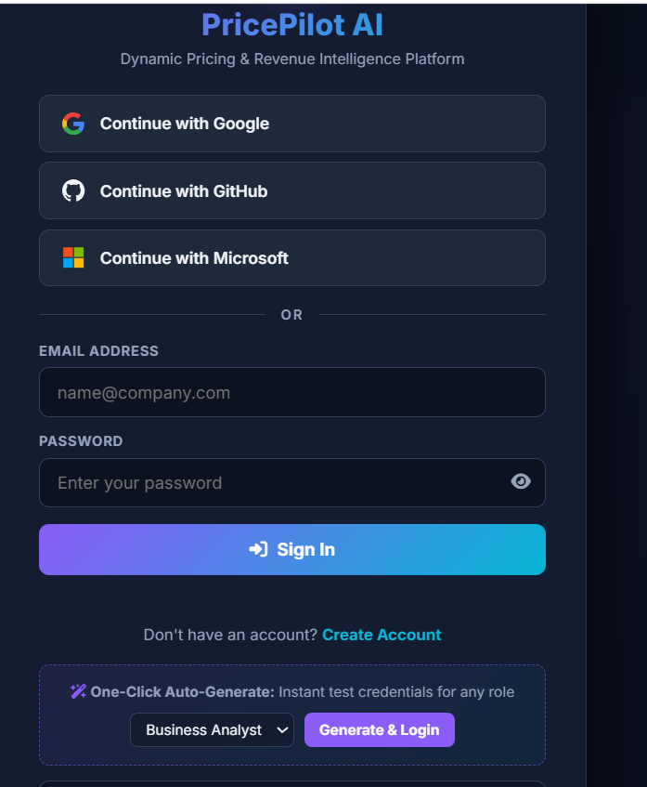

6. Develop Profitability Analytics Dashboards
Profitability analytics dashboards are developed to present important profitability and pricing-related information in an accessible visual format. The dashboards support monitoring of revenue, profitability, pricing performance, and product-level business performance.
Screenshot: 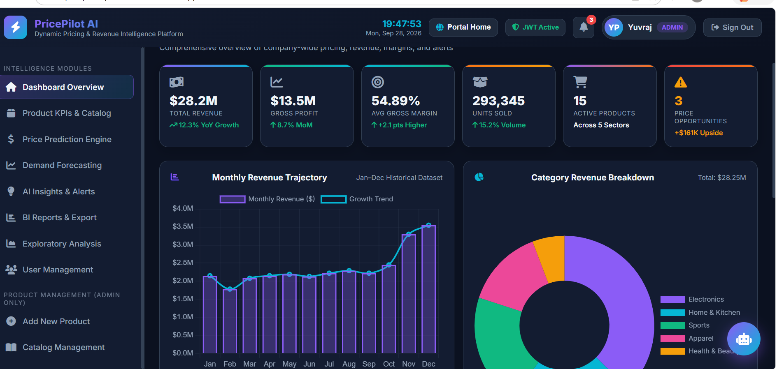

7. Generate Pricing Strategy Recommendations
Pricing strategy recommendations are generated using the available pricing, demand, competitor, and profitability information. The recommendations are intended to support pricing decisions by identifying suitable pricing opportunities and strategies based on the analyzed business information.
Screenshot: 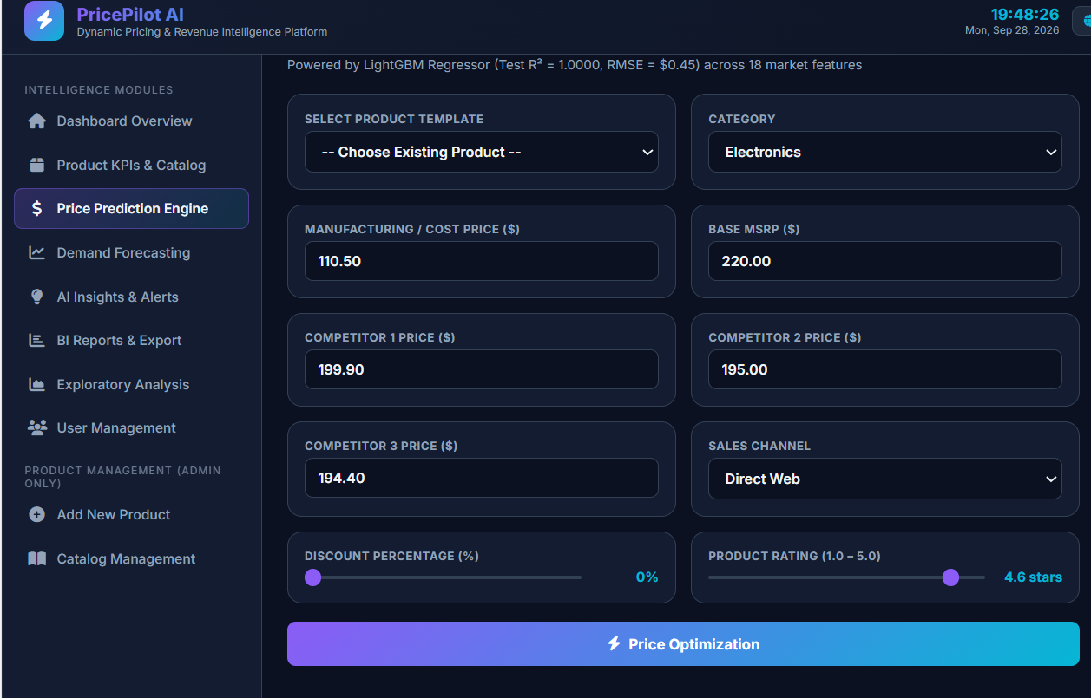

8. Build Executive Business Intelligence Reports
Executive business intelligence reports provide summarized business information for higher-level analysis and decision-making. The reports bring together relevant pricing, revenue, profitability, market, and performance information into a structured business intelligence view.
Screenshot: 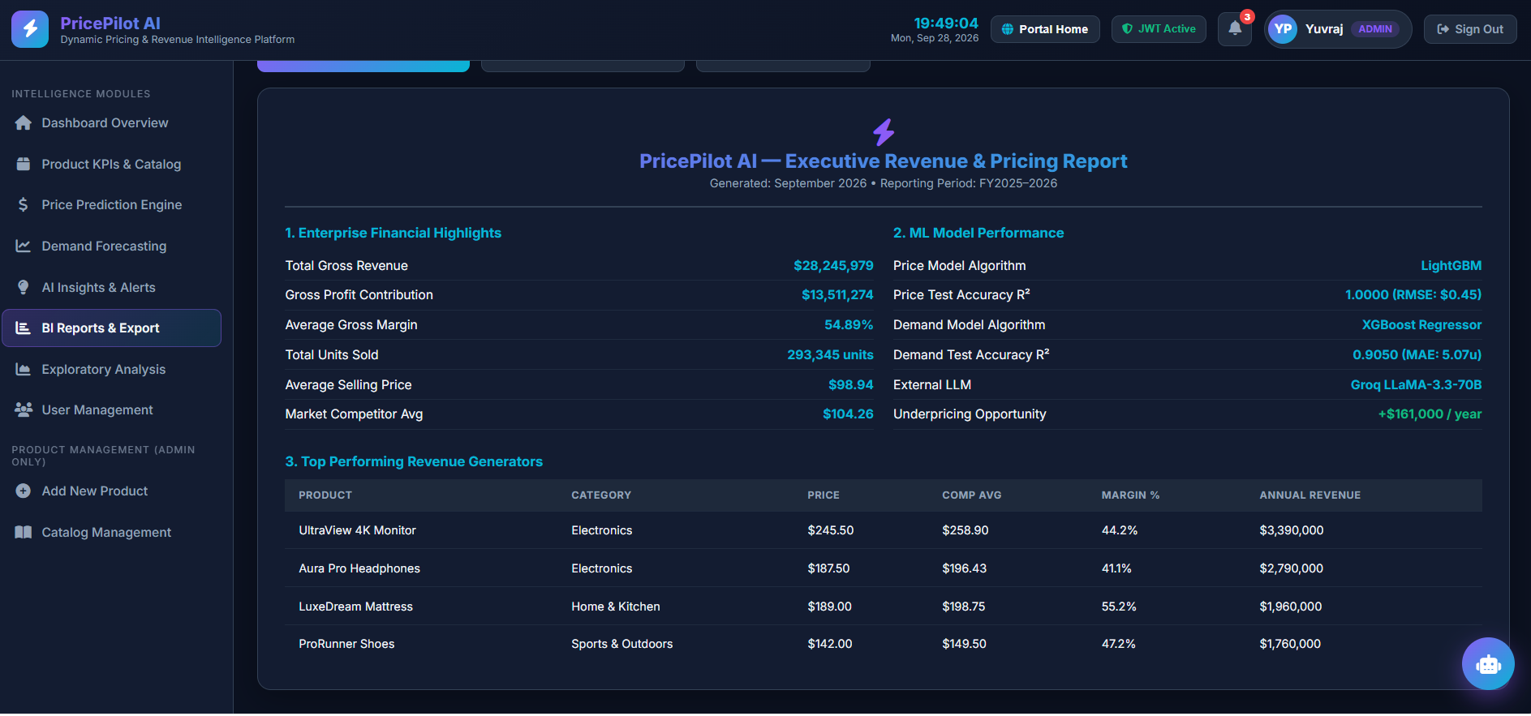

Milestone 3 Outcomes
The expected outcomes of Milestone 3, as defined in the PricePilot AI project document, are:
- Build competitor analysis and revenue optimization systems.
- Implement profitability monitoring and reporting workflows.
- Understand market intelligence and pricing strategy concepts.
- Complete end-to-end pricing optimization workflows.

How Objectives Are Achieved
The Milestone 3 objectives are achieved by integrating competitor pricing, demand, pricing, inventory, profitability, and market-related information into the PricePilot AI platform.
The competitor analysis functionality supports competitor price monitoring, market comparison, competitive positioning, and pricing opportunity detection. The revenue optimization functionality supports revenue simulation, profitability analysis, pricing strategy recommendations, and margin optimization.
The pricing analytics and business intelligence capabilities provide revenue analytics, pricing performance reports, product profitability analysis, and executive-level business intelligence reports.
The combined workflow enables the system to move from competitor and market information to pricing analysis, profitability monitoring, pricing recommendations, and business intelligence reporting.

Conclusion
Milestone 3 extends PricePilot AI from pricing and demand analysis toward competitor analysis and revenue optimization. The milestone focuses on competitor monitoring, pricing comparison, market intelligence, profitability analytics, pricing strategy recommendations, and executive business intelligence reporting.
The completed scope establishes the required workflows for analyzing competitive pricing and profitability and supports the end-to-end pricing optimization process defined for the project.

Submitted by:
Yuvraj Nandu Patil
Email:
yuvrajcet26@gmail.com

